This access statement does not contain personal opinions as to our suitability for those with access needs, but aims to accurately describe the facilities and services that we offer all our guests/visitors.
Access Statement for 4 Greenside, Flamborough

Introduction
Greenside cottages offer of a choice of 2 former fisherman's cottages with views over-looking the village green, in the center of Flamborough. The cottages were built around 1850 but have been fully modernized with gas central heating and UPVC doors and windows.
4 Greenside and 12 Mereside (see separate access statement) can sleep up to 4 people in 2 bedrooms - 1 double and 1 twin.
Both cottages are strictly non-smoking and children and well behaved pets are welcome.
If you have any queries please contact;
Jo - 07828 021051 /01262 850575
email - jo@westscar0408.fslife.co.uk
www.flamboroughgreensidecottages.co.uk
We look forward to welcoming you. If you have any queries or require any assistance please phone 07828 021051 / 01262 850575 or email jo@westscar0408.fslife.co.uk.

Pre-Arrival
- Once payment has been received, along with a receipt, a map of the village with the cottage marked on it will be sent. Alternatively, just enter the postcode YO15 1JZ into a route planner to get directions.
- The nearest railway station is in Bridlington which is 5 miles away. There is a regular bus service from Bridlington to Flamborough, the bus station is on the Promenade in Bridlington. There is a taxi rank at the train station.
- The nearest bus stop to the cottage is about 100yds away.
- The cottage is situated off the main road on a side street, which has a tarmac surface in reasonable condition with no footpath.
- Eden Mobility in Bridlington supplies equipment for hire. For further details phone 01262 410163 or visit www.eden-mobility.co.uk/livingaids.
- The nearest Shopmobility can be found in the Promenade shopping center Bridlington
- Flamborough's High Street is only a couple of minutes’ walk away and has a good variety of shops Inc. Co-Op, Butchers, Bakers, Paper shop/Post Office, Hair dressers and Fish and Chip shops.
- Well behaved pets are welcome and a dog bed is provided.
- This access statement is available in larger print on request.
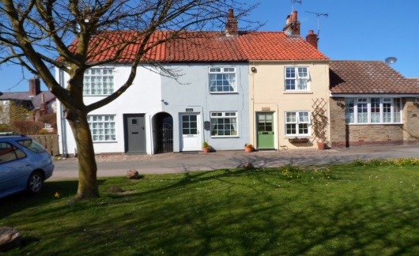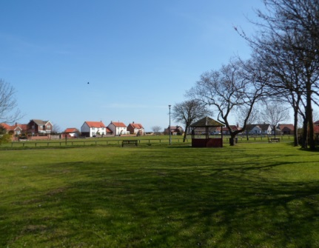
Key Collection, Welcome and Car Parking
- 4 Greenside is fitted with a key safe that is located alongside the back door. On receipt of payment, details of the lock combination will be forwarded.
- Occupancy can be taken from 2pm on the day of arrival.
- Free parking is available outside the cottage.

Entrance to Property
- The property is accessed straight off the road - no kerb.
- The front door is 1/2 glazed UPVC opening inward. The door width is 30" (76cms) with a step from the road surface of 7" (18cms) and leads directly into the living room.
- The back door again is 1/2 glazed UPVC opening inwards, into the kitchen. The door width is 29" (74cms) with a step of 6" (15.5cms).
- Access to the back door is through a communal passageway with lighting from a motion sensor solar light.

Halls, Stairs, Landings, Passageways
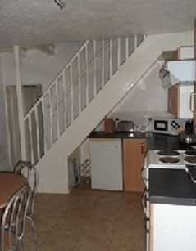
The stairs and landing are well lit with a combination of natural light and ceiling light. The floor covering is short pile carpet.
The stairs are accessed from the kitchen. The staircase width is 27.5" (70cms) with 11 steps. There are handrails on both sides.
- The landing is L shaped and is 31" (79cms) wide with access to both bedrooms and shower room.

Sitting Room/Lounge
- The living room is situated on the ground floor
- The room has a 2 seater and 3 seater settees with non-feather cushions and a nest of 3 small tables.
- All furniture is moveable.
- There is a Freeview TV with built in DVD, subtitles and remote control.
- Lighting is natural daylight through UPVC window with ceiling light and wall-lights.
- Flooring is laminate with a fire-side rug.
- Heating is provided through a wall mounted room radiator and there is an electric fire set back into the chimney breast
- .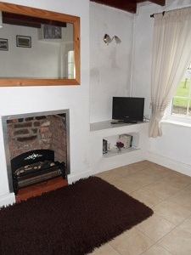 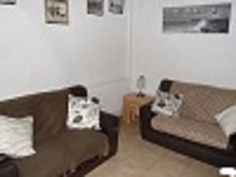

Kitchen
- The kitchen is situated on the ground floor with step free access from the living room through a door which is 292(74cms) wide.
- Fully equipped modern kitchen with plenty of both wall units and under counter cupboards. Counter top height is 39" (99cms)
- There is a free-standing electric double oven, both oven doors drop downwards. Under counter fridge with moveable shelves. The highest being 17" (43cms) and the lowest 8"(20.5cms) both measurements taken from base of fridge.
- Cups, plates, etc. can be moved from wall units to under-counter cupboards if required, please advise on booking.
- Cordless kettle rotating 360
- Circular dining table with 4 chairs, all moveable. Table height is 30" (76.5cms)
- Lighting is natural daylight with ceiling spot lights.
- Heating from wall mounted radiator.
- 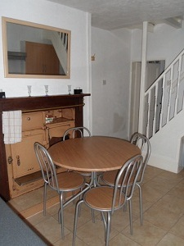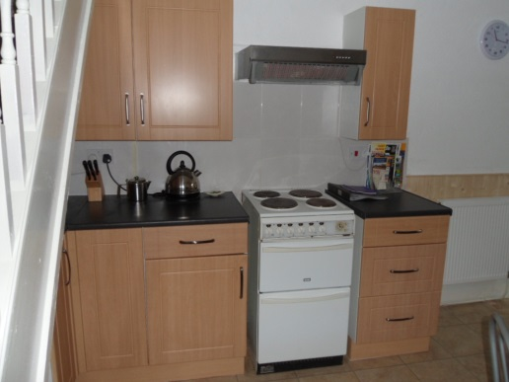

Bedrooms and Sleeping Areas
- Both bedrooms accessed off the landing on the first floor.
- The front bedroom door is 29" (74cms) and opens into the bedroom.
- There are 2 single beds. the height of both beds from the top of the mattress to the floor is 22" (56cms), with under bed clearance of 13.3" (34.5cms)
- Mattress protectors are fitted and duvets and pillows are non feather.
- All bed-room furniture is free -standing and moveable.
- Good contrast between walls and the wood laminate flooring.
- Lighting is from natural daylight through UPVC window with ceiling light and bed-side table lamps.
- The back bedroom door opens inwards and is 29"(74cms) wide.
- A double bed with mattress height from floor of 22"(56cms) and under bed clearance of 12"(30.5cms)
- Free standing moveable bedroom furniture.
- Lighting is from natural daylight through UPVC window with ceiling light and bedside table lamps.
- Good contrast between walls and wood laminate flooring.
- Heating from wall mounted radiator in each room.

Bathrooms, Shower-rooms and Toilets
- Accessed off the 1st floor landing with a door width of 26" (66cms)
- Corner shower cubicle 28"x28" (71cms x 71cms) with a folding door opening width of 19" (48.5cms). Step height into shower off floor level is 9" (23cms)
- Toilet height 15" (38cms)
- Basin height 31" (79cms)
- Lever taps on washbasin
- Lighting from natural daylight through frosted UPVC window and ceiling light
- Wood laminate flooring with bath matt.
- Good contrast between walls and ceiling

Garden
- 4 Greenside has a small shared yard.
- Directly opposite the back door is a large shed with door opening width of 30" (76cms) and a step up of 9" (23cms)
- The shed houses a chest freezer - top opening and a standard size washing machine - front opening.
- Natural lighting through window with overhead light.

Additional Information
- Mobile phone signals can be poor.
- The nearest hospital is in Bridlington, please note that it only operates a minor injuries unit.
- The nearest A & E is at Scarborough hospital 15 miles away.
- There is a Doctors surgery in Flamborough about 300 yards from the cottage.
- all above details can be found in the welcome brochure.

Contact Information
Address (Inc. postcode): | 4 Greenside Flamborough East Yorkshire YO15 1JZ
Telephone: | 07828 021051 / 01262 850575
Email: | jo@westscar0408.fslife.co.uk
Website: | www.flamboroughgreensidecottages.co.uk
Grid Reference: | TA227706
Local Equipment Hire: | Eden Mobility, Bridlington Tel 01262 410163
Local Accessible Taxi: | Tel; 01262 851888 Tel; 01262 851515
Local Public Transport: | East Yorkshire Motor Services, bus route 510. Time tables are available in the cottage.

